**CHANDIGARH UNIVERSITY**

**UNIVERSITY INSTITUTE OF ENGINEERING**

**DEPARTMENT OF COMPUTER SCIENCE AND ENGINEERING**



|  |  |
| --- | --- |
| **Submitted by:**  Yash Gupta  20BCS5009 | **Submitted To:**  Er. Bhupinder Singh  (12856) |
| **Subject Name:** | Multimedia Technologies Lab |
| **Subject Code:** | 20CSP-339 |
| **Branch:** | CSE |
| **Semester:** | 5th |

LAB INDEX

|  |  |  |  |  |  |  |  |
| --- | --- | --- | --- | --- | --- | --- | --- |
| **Sr.No** | **Program** | **Date** | **Evaluation** | | | | **Sign** |
| **LW(12)** | **VV(8)** | **FW(10)** | **Total (30)** |
|  |  |  |  |  |  |  |  |
|  |  |  |  |  |  |  |  |
|  |  |  |  |  |  |  |  |
|  |  |  |  |  |  |  |  |
|  |  |  |  |  |  |  |  |
|  |  |  |  |  |  |  |  |
|  |  |  |  |  |  |  |  |

**Experiment 10**

**Student Name: Yash Gupta UID: 20BCS5009**

**Branch: BE-CSE Section/Group: 20BCS-MM-806 A**

**Semester: 5 Date of Performance: 29-09-2022**

**Subject Name: MMT LAB Subject Code:**

**Aim :-**

Draw a circle to represent a drum and edit as required on one layer. Insert another layer, draw suitable drumsticks and position them appropriately. Give visual effects. Also provide an audio effect by selecting the sound item from Flash library Sounds.fla, so as to integrate audio and video clips using Macromedia flash.

**Hardware Requirements: -**

Minimum 384MB RAM, 100 GB hard Disk, processor with 2.1 MHz.

**Software Requirements: -**

Macromedia Flash.

**Tools Used : -**

* Adobe Photoshop
* Macromedia flash.

**Steps :-**

Step 1:

Go to Macromedia Flash 8, click on the flash document→click ok.

Step 2:

Double click on layer one and rename it as a drum.

Step 3:

Using the oval tool draw a drum.

Step 4:

Go to the 20th frame and insert a keyframe (F6).

Step 5:

Create another layer and rename it as a stick.

Step 6:

Using the line tool, draw stick for the drum and convert it into a symbol (F8).

Step 7:

To move to stick up and down i.e., beating, set the position in between the 1st to 20th frame and insert a key frame (F6) in the timeline.

Step 8: Repeat the step 6 and 7 to create another stick.

Step 9: Press Ctrl + Enter to test the movie.

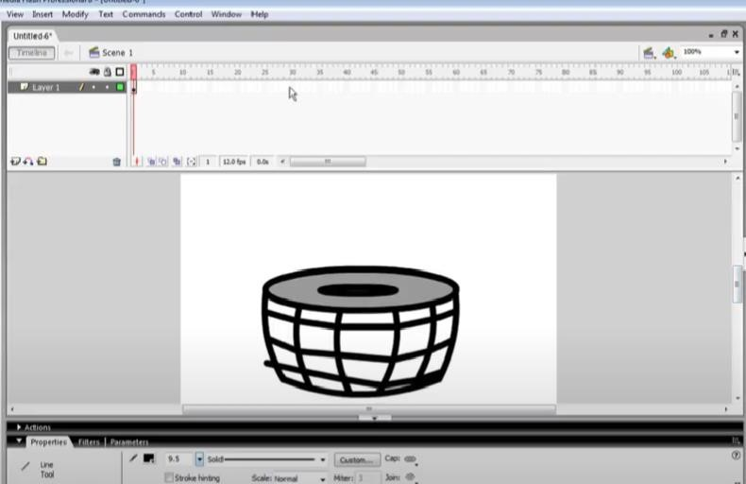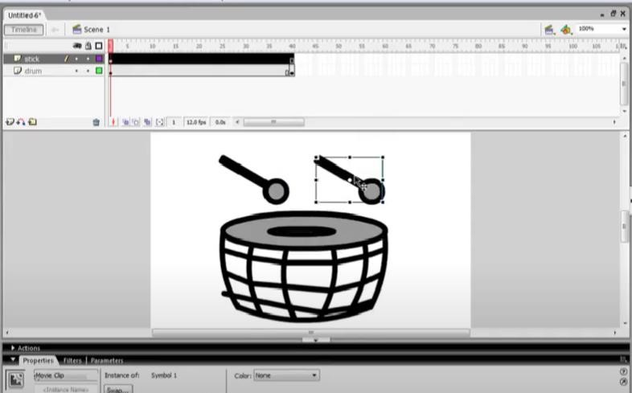

# Output :-

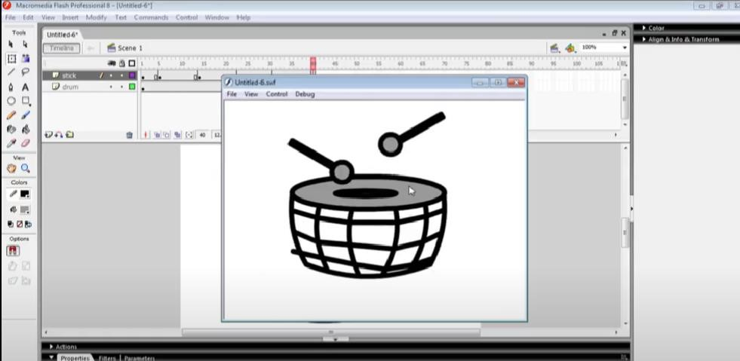

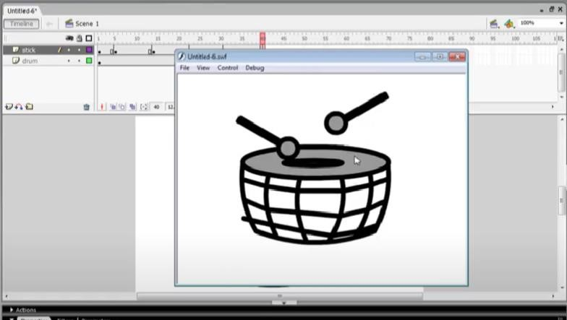

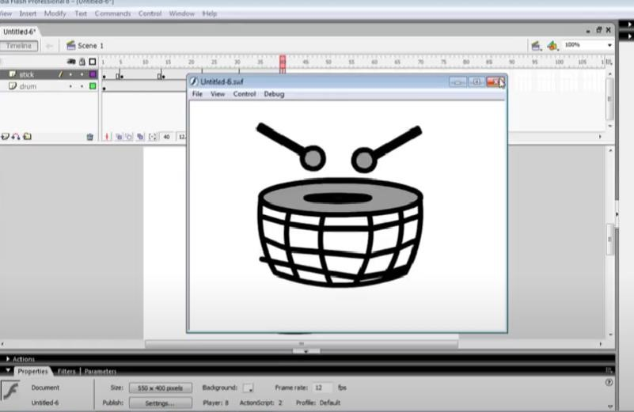

**Evaluation Grid (To be created as per the SOP and Assessment guidelines by the faculty):**

|  |  |  |  |
| --- | --- | --- | --- |
| Sr. No. | Parameters | Marks Obtained | Maximum Marks |
| 1. |  |  |  |
| 2. |  |  |  |
| 3. |  |  |  |